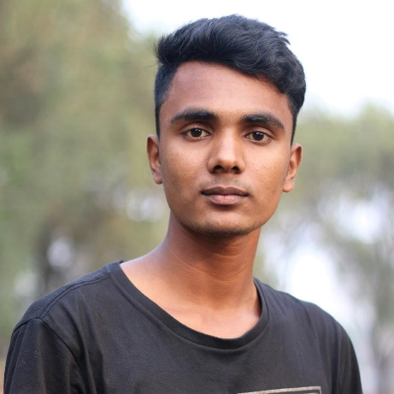

**Sujon Hossain**

**Font-End Developer & Quick Learner**

**PROFILE**

**SUMMARY**

I’m Font-End Web Developer. I have built several HTML templates for small business. Looking at a design I can convert it into a HTML CSS template with pixel perfect precision. I use bootstrap very often, so the turn around of my project is very quick.

Currently I’m looking React and I’m looking for a position where I can progress and challenge my skills.

1. **Implemented a store management software for managing sales, purchase, and inventory.**
2. **Developed an e-commerce site with Font-End using Html CSS, JavaScript, Bootstrap.**
3. **Skills: HTML, CSS, Bootstrap, JavaScript, jQuery, Web-Design, OOP, GitHub etc.**

**EXPERIENCE**

**CONTACT**

**Fashion House Sales Management, (Jun, 2019 – July, 2019)**

* **Developed customer order processing unit.**
* **Created store inventory management to add new items, set price, check quantity and price.**
* **Technology: JavaScript, basic programming, OOP, search algorithm and sort algorithm.**

391-mail4.png

sujon.hossain758@gmail.com

067-phone.png

01980-653626

001-home.png

Mirpur-10, Mirpur Dhaka-1216

202-sphere.png

[www.linkedin.com/sujonhossain](http://www.linkedin.com/sujonhossain)/

**Many Various HTML Template Projects (Jan, 2019 – May, 2019)**

* **BRAND HERA**
* **STUDENT PROTFOLIO**
* **PERSONAL WEBSITE**
* **STUDENT PERSONAL WEBSITE**
* **DHASBOARD**
* **E-COMMERCE TEMPLATE**

202-sphere.png

[www.sujonhossain.github.oi](http://www.sujonhossain.github.oi)

**EDUCATION**

**Institute Science Trade and Technology**

**Computer Science and Engineering**

**BSc in CSE**

**Session-2018-2019**

**Leadership and Social Activities**

**Front end Developer**

**2017**

* Member of ACM Chapter (Institute Science Trade and Technology)
* Class Captain, Dhaka Golden College.

**Dhaka Golden College**

**HSC- Science**

**GPA-3.67**